AiManga PLAN

Plan:
Models:
Comments:
- Id
- Author_id
- Page_id

User:
- id
- preferable stuff
Admin:
Translator:
Manga:
-Title
-id
-image
Volume:
-id
-manga_id
Oblozhka neobyazatel’no
Glava:
-id
-image
-volume_id

Page:

https://mintmanga.live/
Composition:
Header:
-Color Themes (?)
-Genre Navigation
-Search
-Account page link
-Genre Sort

Main page:
-Manga
-News
-Recent release

Catalogue Page:
[Paginazia/ Pagination]
-All genres links and little bit of showing manga

Spec Sorted Page:
[Paginazia/ Pagination]
Manga with common theme

Manga page:
-Image page(interactable with buttons (javascript or bootstrap learning))
-Comments(simple stuff)
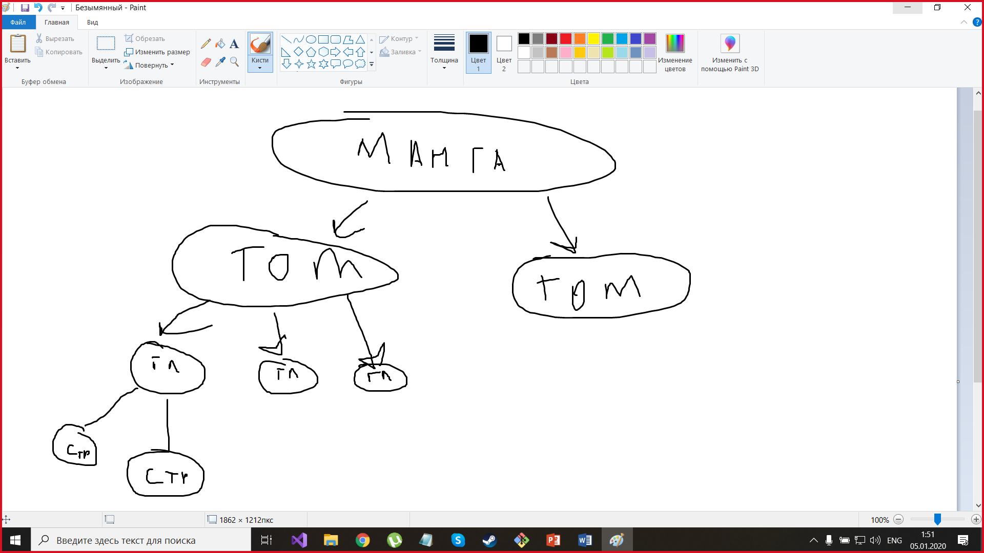

User Page:
-Add to favorites
-Creation of user collection

Translator Page: (bool is-trans)
-Own translations
-Editing own Translations
-Add new manga

Admin Page: (Boolean stuff is-admin)
-Banning users
-All users list
-Content list
-Ban content

